Name :Soham Asalmol
PRN : 202501050018
Course : EDS

Practical 1
1)
Program :
mass = float(input())
velocity = float(input())
momentum = mass * velocity
print(f"{momentum:.2f}kgm/s")

Output :
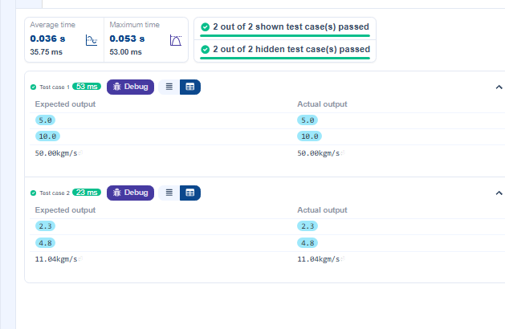

2)
Program :
n = int(input())
if 1<= n<=9:
print(n ** 2)
elif 10 <= n <= 99:
print(f"{n ** (1/2):.2f}")
elif 100 <= n <= 999:
print(f"{n ** (1/3):.2f}")
else:
print("Invalid")
Output :
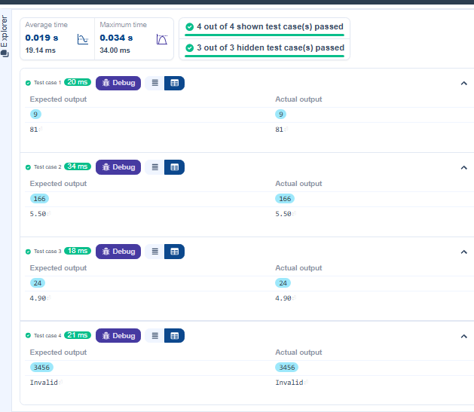
3)
Program :
from datetime import date
from datetime import datetime
date1 = input().strip()
date2 = input().strip()
d1 = datetime.strptime(date1,"%Y-%m-%d")
d2 = datetime.strptime(date2,"%Y-%m-%d")
difference = d2 - d1
print(difference.days)
Output :
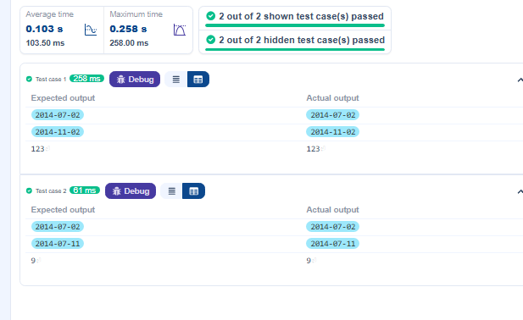

4)
Program :
num = int(input())
r_num = 0
while num != 0:
digit = num % 10
r_num =r_num * 10 + digit
num = num // 10
print(r_num)
Output :
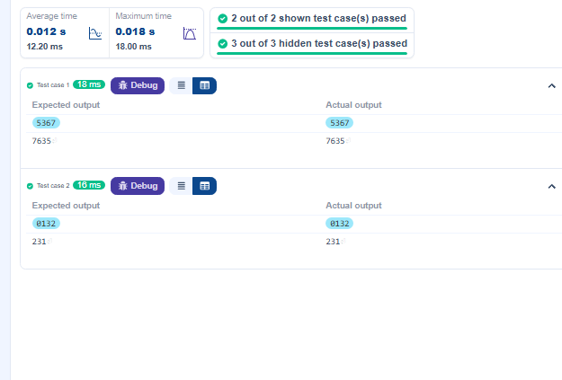

5)
Program :
num = int(input())
for i in range(1, 11):
print(f"{num} x {i} = {num * i}")
Output :
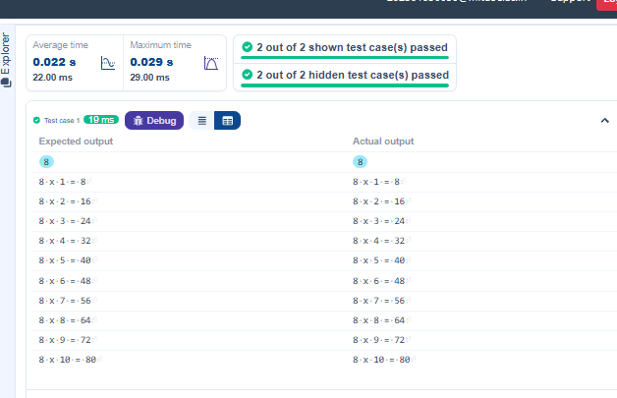

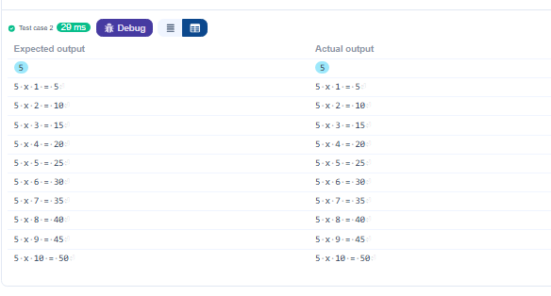

6)Program :
# write your code
n = int(input())
marks = list(map(int, input().split()))
failed = False
for m in marks:
if (m <40):
failed=True
break
if failed:
print("Fail")
else:
total = sum(marks)
agg = total / n
print("Aggregate Percentage: "f"{ agg:.2f}")
if agg > 75 :
print("Grade: Distinction")
elif (agg >= 60):
print("Grade: First Division")
elif (agg >= 50):
print("Grade: Second Division")
elif(agg >= 40):
print("Grade: Third Division")
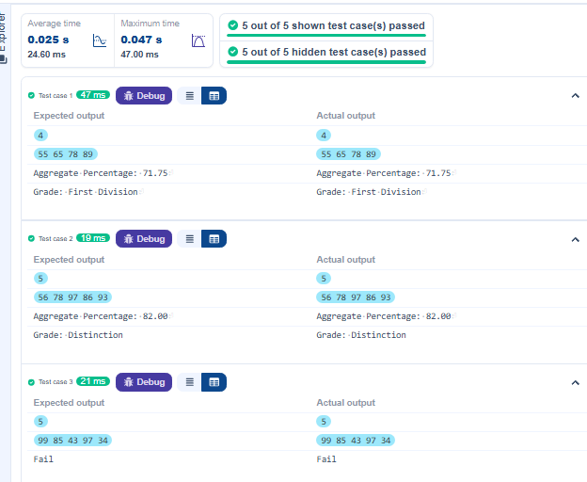
Output :
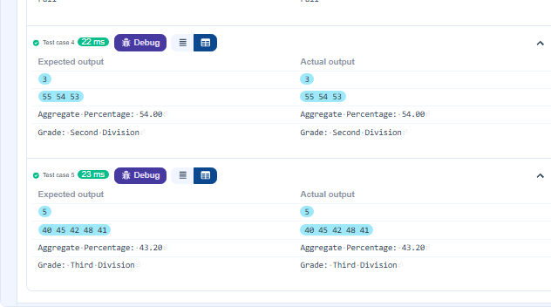

7) Program :
def fibonacci(n):
if n == 1:
return 0
elif n == 2:
return 1
else:
return fibonacci(n-1) + fibonacci(n-2)
n = int(input())
for i in range(1, n + 1):
print(fibonacci(i), end=" ")
Output :
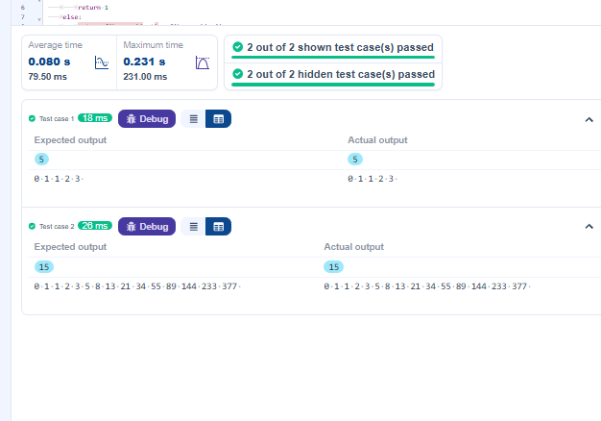

8)
Program :
#Type Content here...
n = int(input())
for i in range(1, n + 1):
print('* ' * i)
Output :
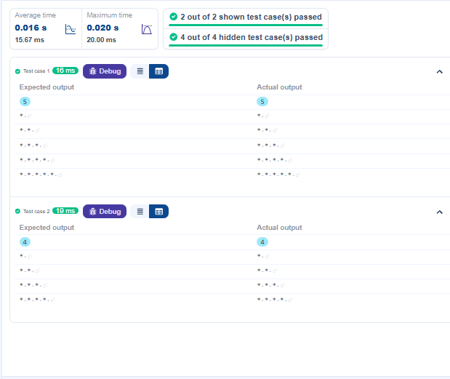

9)
Program :
# Type Content here...
n = int(input())
for i in range(1,n+1):
for j in range(1,i+1):
print(j,end = " ")
print()
Output :


